Our Goals for Today (lect. 3)

1. Non-Newtonian Fluids
2. Various ways to study fluid dynamics

Newtonian vs Non-Newtonian Fluid

See the PPT

* There are three fundamental ways to study fluid mechanics

1. Integral approach
2. Differential approach
   1. Mostly done these days using CFD (Computational Fluid Dynamics)
3. Experimental approach

Many times, a combination of these approaches lead to the best or most efficient solution

Integral approach

* When flow is analyzed on a system level basis, e.g. using a control volume encompassing the system (a pump, or an airfoil)
* Used when
  + Details of flow are not interesting but the overall effect or outcome of it are important (e.g. pump work, or lift on an airfoil)
* Usually less labor or resource intensive than differential method

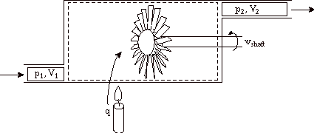

Differential analysis

* We calculate flow at every point in the flow field i.e. (x,y,z,t).
* So the flow properties like P, T, and characteristics, e.g. Vel. Is know at every point
* Such detailed knowledge useful for understanding flow separation, (drag and lift), or pressure loss at fittings, etc.
* Need to solve the differential equations of motion, or detailed experiments (e.g. using PIV method)
* A costly approach

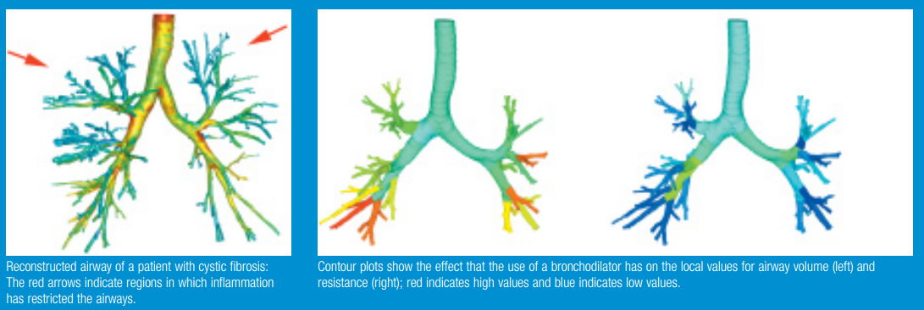

Experimental Approach

* Example: use of PIV (particle image velocimetry) to understand flow field

Flow visualization

* Stream line stream tube

Streamlines show **local flow direction**, not velocity! Velocity normally varies along a streamline

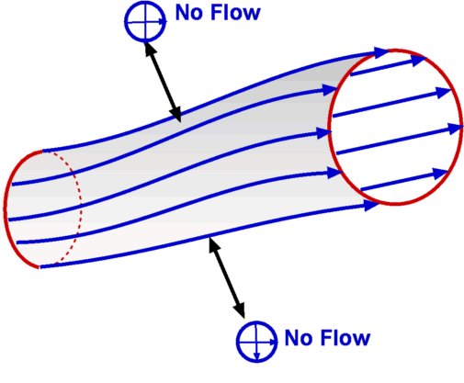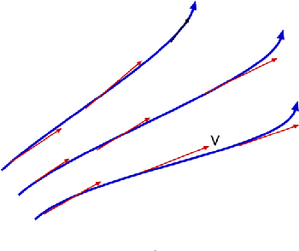

Eularian and Lagrangian frames of reference

* Two methods to describe fluid motion (usually mathematically), but same answer!
* The Eularian approach focuses on fluid properties/velocity at a point (x,y,z,t). This is a field approach.
  + Used in majority of cases and intuitive
* In Lagrangian approach a particle or a group of particles are followed in time.
  + This is a bit of cumbersome method of analysis
  + Useful for cases such as particle laden flows (drug delivery to lung), or two phase flow involving bubbles (oil industry).